MEMORY MANAGEMENT SIMULATOR ARCHITECTURE DIAGRAM



SUPERVISOR
MR. MEHTAB MUSHTAQ

SUBMITTED BY

SADIA AKRAM
2021-UOK-03944
IRAJ RAMZAN
2021-UOK-03904
ASMA KARIM
2021-UOK-03928

SESSION 2023-2027

UNIVERSITY OF KOTLI AZAD JAMMU AND KASHMIR
FACULTY OF COMPUTING & ENGINEERING
DEPARTMENT OF CS&IT
20 FEB, 2026

Contents
1. INTRODUCTION 1
1.1 Background 1
1.2 Purpose of This Document 1
1.3 Project Scope 1
2. REQUIREMENT SPECIFICATION 1
2.1 System Overview 1
2.2 Problem Statement 1
2.3 Project Objectives 2
2.3.1 General Objectives 2
2.3.2 Specific Goals 2
2.4 Functional Requirements 2
2.4.1 Memory Initialization 2
2.4.2 Process Allocation 2
2.4.3 Allocation Algorithms 2
2.4.4 Process Deallocation 2
2.4.5 Memory Map Display 3
2.5 Non-Functional Requirements 3
2.6 Assumptions and Constraints 3
3. SOFTWARE ARCHITECTURE DESIGN 3
3.1 Architecture Style 3
4. SOFTWARE ARCHITECTURE DIAGRAM 4
5. MODULE DESCRIPTIONS (DETAILED) 5
5.1 User / Process Layer 5
5.2 Simulator Logic Layer (Core System) 5
5.2.1 Process Scheduler 5
5.2.2 Memory Allocator 5
5.2.3 Allocation Algorithm Module 5
5.2.4 Linked List / Array Manager 5
5.2.5 Console Output & Monitoring Module 5
5.3 Simulated Physical Memory Layer 6
6. DATA FLOW EXPLANATION 6
7. HOW ARCHITECTURE REFLECTS REQUIREMENTS 6
8. CONCLUSION 7
9. REFERENCES 7

INTRODUCTION

Background
Memory management is one of the most important responsibilities of an operating system. It ensures that processes receive memory efficiently while minimizing fragmentation and preventing overlap between processes.
Modern operating systems use advanced techniques like paging and segmentation. However, understanding the basic concept of contiguous memory allocation is essential for students learning operating systems.

Purpose of This Document
This document describes the software architecture of the Memory Management Simulator. It explains system modules, interactions, data flow, and how the architecture reflects the system requirements defined in Assignment-1.

Project Scope
The project simulates:
- Memory allocation to processes
- Memory deallocation
- Memory fragmentation
- Allocation strategies comparison
- Console-based visualization of memory map
The simulator does not include:
- Paging
- Virtual memory
- Multithreading
- Real OS hardware interaction

REQUIREMENT SPECIFICATION

System Overview
The Memory Management Simulator is a C++ console application that imitates how an operating system manages RAM using contiguous partitioning.
It creates a virtual memory space and maintains it using dynamic data structures such as linked lists or arrays.
The system tracks both allocated blocks and free holes.

Problem Statement
Understanding how memory fragmentation occurs during allocation and deallocation is difficult in theory.This simulator provides a step-by-step visualization of memory blocks and addresses, allowing students to observe how allocation strategies affect memory usage.

Project Objectives

General Objectives
- Demonstrate internal OS memory logic
- Show memory fragmentation visually
- Compare allocation strategies
- Track memory blocks dynamically

Specific Goals
- Use linked lists or arrays for memory tracking
- Simulate real memory addresses
- Implement First-Fit, Best-Fit, and Worst-Fit
- Show memory state after each operation

Functional Requirements

Memory Initialization
- System asks user to enter total memory size.
- Entire memory starts as one free block.
- OS reserved memory is allocated first.

Process Allocation
- User enters process ID and size.
- System selects allocation algorithm.
- Memory block assigned if space exists.
- If no block fits, system shows allocation failure.

Allocation Algorithms
- First-Fit
System selects the first free block large enough for the process.
- Best-Fit
System selects the smallest suitable block to reduce wasted space.
- Worst-Fit
System selects the largest free block to keep large holes available.

Process Deallocation
- User removes process by PID.
- Block becomes free.
- Adjacent holes merge to reduce fragmentation.

Memory Map Display

System prints:
- Start address
- Block size
- Process name
- Free memory
- Memory layout sequence

Non-Functional Requirements

- Language: C++
- Platform: Console based
- Data structures: Linked list / vector
- Reliability
- Validate user inputs
- Prevent invalid deletion
- Prevent memory overflow
- Maintain stable execution

Assumptions and Constraints

- Memory is contiguous
- RAM size fixed at start
- Each process must fit in one block
- Paging and segmentation are not included

SOFTWARE ARCHITECTURE DESIGN

Architecture Style

The system follows a Layered Architecture Model because memory management involves hierarchical control from user input to hardware simulation.
- User/Process Layer
- Simulator Logic Layer
- Simulated Physical Memory Layer

MEMORY MANAGEMENT ARCHITECTURE DIAGRAM

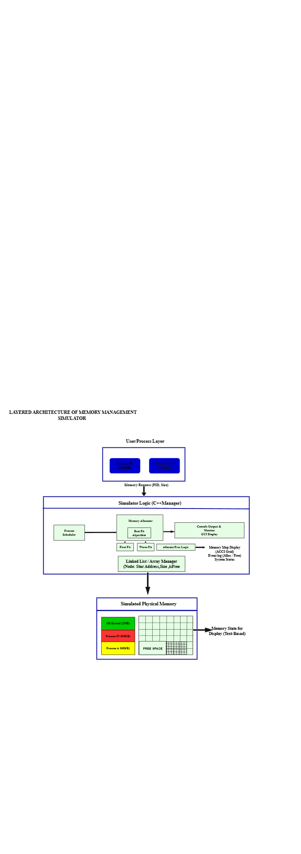Figure 1: Layered Architecture of Memory

MODULE DESCRIPTIONS (DETAILED)

User / Process Layer
This layer represents processes created by the user.
Each process sends a request containing its ID and required memory size.
The layer acts as the system input interface and initiates memory operations.

Simulator Logic Layer (Core System)
This is the most important layer of the architecture.
It processes requests, applies allocation algorithms, updates memory structures, and produces output.

Process Scheduler
The scheduler receives process requests and forwards them to the allocator.
It ensures operations occur in sequence and maintains system flow.

Memory Allocator
The allocator determines where a process should be placed in memory.
- It checks available holes, applies the selected algorithm, and updates memory blocks.
- It also handles freeing memory and merging adjacent blocks.

Allocation Algorithm Module
This module contains implementations of:
- First-Fit search strategy
- Best-Fit search strategy
- Worst-Fit search strategy
It determines which free block will be used for allocation.

Linked List / Array Manager
This component stores memory blocks as nodes.
Each node contains:
- Starting address
- Block size
- Allocation status
- Process ID
The structure dynamically changes after allocation and deallocation.

Console Output & Monitoring Module

This module shows system output.
It prints:
- Memory layout
- Allocation events
- Errors
- System status
It also displays the memory map in text format.

Simulated Physical Memory Layer
This layer represents the virtual RAM space.
It includes:
- OS kernel reserved memory
- Allocated process blocks
- Free space
It visually demonstrates how memory is divided after each operation.

DATA FLOW EXPLANATION
The system processes data in the following sequence:
- User enters process request
- Request goes to scheduler
- Scheduler forwards to allocator
- Allocator selects algorithm
- Memory list updated
- Output displayed
- Memory map refreshed
This flow ensures controlled memory allocation and accurate system tracking.

HOW ARCHITECTURE REFLECTS REQUIREMENTS
The architecture directly implements Assignment-1 requirements:
- Allocation algorithms → handled by allocator module
- Memory structure → managed by linked list manager
- Console output → handled by output module
- Memory map → represented in physical memory layer
This ensures design consistency between requirements and implementation.

CONCLUSION
The Memory Management Simulator architecture clearly separates system responsibilities into layers and modules.
This design improves system organization, simplifies implementation, and allows easy modification of allocation strategies.
The simulator effectively demonstrates how operating systems manage memory and provides an educational visualization of fragmentation and allocation behavior.

REFERENCES
Memory Management Tutorials (YouTube)
C++ Documentation
Previous Assignment Proposal Document
Assistance was taken from Open AI ChatGPT to understand the layered architecture approach and system module relationships.
Various explanations and diagrams were studied using Google search to better understand layered diagrams and software architecture design concepts.

